Machine learning Lab Observation
ITA0614
Experiment 4
Build an Artificial Neural Network by implementing the Backpropagation algorithm and test the same using appropriate data sets.
Name : HARIHARAN GB
Reg.No : 192412390
Problem 1 : XOR Gate
Aim
To build a 2-4-1 neural network with the backpropagation algorithm and train it to learn the XOR logic gate.
Algorithm
- Initialise all weights and biases with small random values and choose a learning rate.
- Present a training input to the network and perform the forward pass: hidden output h = f(W1.x + b1) and network output o = f(W2.h + b2), where f is the activation function.
- Compute the error between the target t and the output o (mean squared error or cross-entropy).
- Backward pass: calculate the output-layer delta d_o = (t - o) * f'(o) and propagate it back to get the hidden-layer delta d_h = (W2 transpose . d_o) * f'(h).
- Update the weights and biases: W2 = W2 + lr * h transpose . d_o and W1 = W1 + lr * x transpose . d_h (biases are updated with the summed deltas).
- Repeat steps 2 to 5 for the required number of epochs, or until the error becomes small enough.
- Test the trained network on the training / test data and on a new sample to obtain the predicted output.
Program:
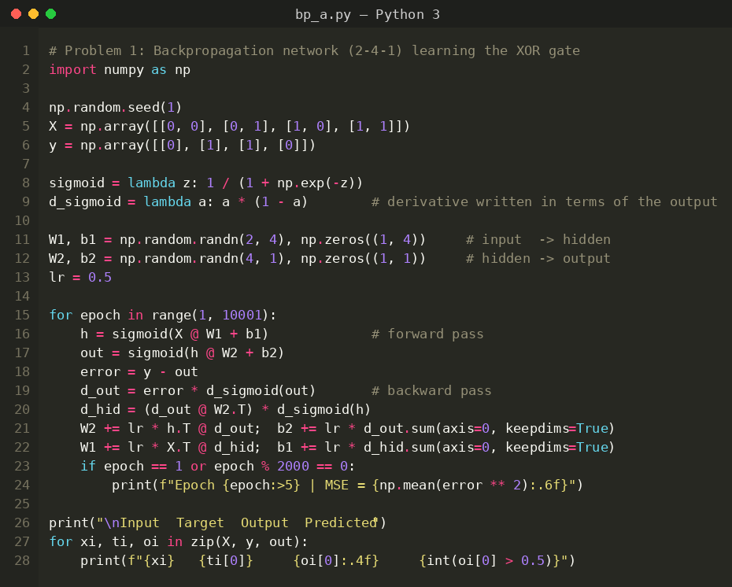
Input
XOR truth table: 4 training patterns with 2 binary inputs and 1 binary target. XOR is not linearly separable, so a hidden layer is required. Sigmoid activation and mean squared error are used.
Input A | Input B | Target (A XOR B)
0 | 0 | 0
0 | 1 | 1
1 | 0 | 1
1 | 1 | 0
Output
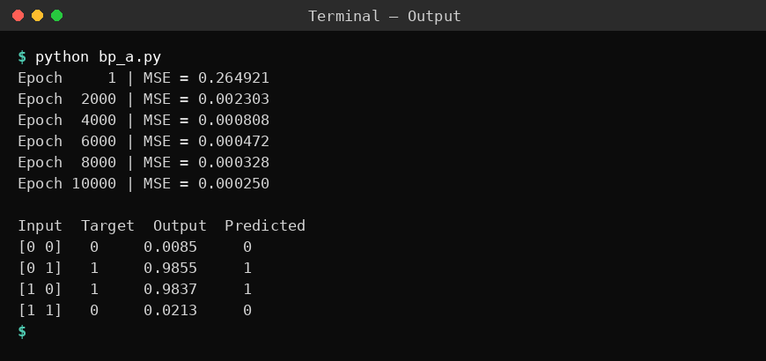
Result
The network trained with backpropagation learned the XOR function: the mean squared error fell from 0.264921 to 0.000250 in 10000 epochs. The outputs 0.0085, 0.9855, 0.9837 and 0.0213 give the predictions 0, 1, 1, 0, which match all four targets.
Problem 2: Student Pass / Fail Prediction
Aim
To train a function-based backpropagation network that predicts whether a student passes from the study hours and attendance, and test it on new students.
Algorithm
- Initialise all weights and biases with small random values and choose a learning rate.
- Present a training input to the network and perform the forward pass: hidden output h = f(W1.x + b1) and network output o = f(W2.h + b2), where f is the activation function.
- Compute the error between the target t and the output o (mean squared error or cross-entropy).
- Backward pass: calculate the output-layer delta d_o = (t - o) * f'(o) and propagate it back to get the hidden-layer delta d_h = (W2 transpose . d_o) * f'(h).
- Update the weights and biases: W2 = W2 + lr * h transpose . d_o and W1 = W1 + lr * x transpose . d_h (biases are updated with the summed deltas).
- Repeat steps 2 to 5 for the required number of epochs, or until the error becomes small enough.
- Test the trained network on the training / test data and on a new sample to obtain the predicted output.
Program:
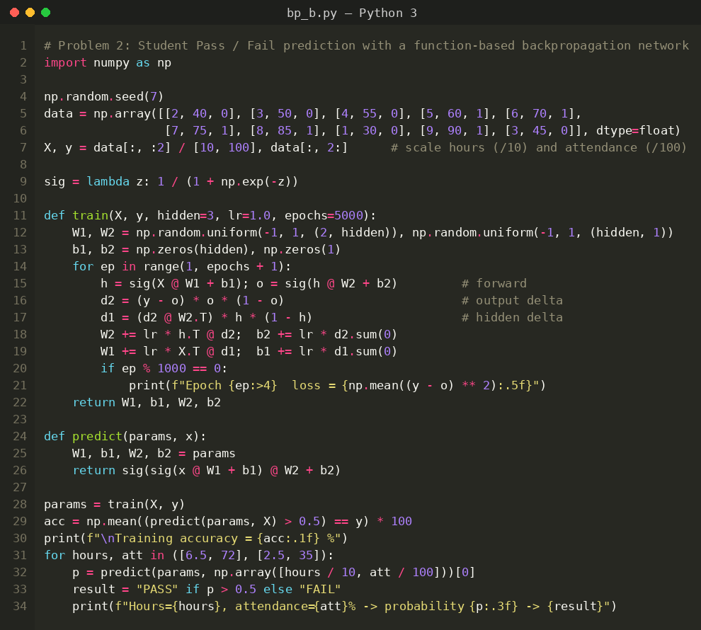
Input
Student data set: 10 training examples with 2 inputs (study hours per day, attendance %) and the target Result (1 = Pass, 0 = Fail). Hours are divided by 10 and attendance by 100 before training. New students tested: (6.5 h, 72 %) and (2.5 h, 35 %).
Study Hours | Attendance % | Result
2 | 40 | 0 (Fail)
3 | 50 | 0 (Fail)
4 | 55 | 0 (Fail)
5 | 60 | 1 (Pass)
6 | 70 | 1 (Pass)
7 | 75 | 1 (Pass)
8 | 85 | 1 (Pass)
1 | 30 | 0 (Fail)
9 | 90 | 1 (Pass)
3 | 45 | 0 (Fail)
Output
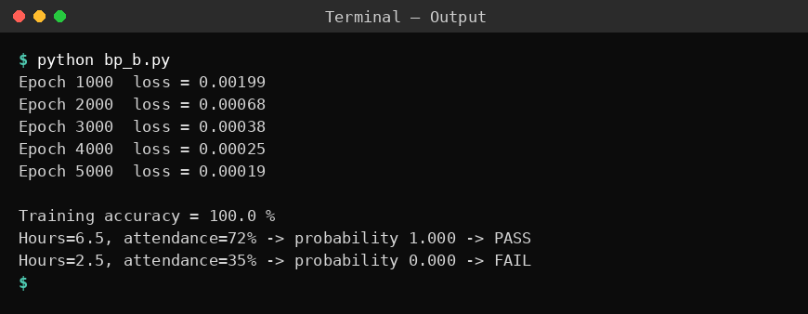
Result
The loss decreased from 0.00199 at epoch 1000 to 0.00019 at epoch 5000 and the training accuracy reached 100 %. The new student (6.5 hours, 72 % attendance) is predicted PASS (probability 1.000) and the student (2.5 hours, 35 % attendance) is predicted FAIL (probability 0.000).
Problem 3: Exam Score Prediction
Aim
To implement a class-based 2-3-1 neural network with backpropagation that predicts the test score from the hours slept and the hours studied.
Algorithm
- Initialise all weights and biases with small random values and choose a learning rate.
- Present a training input to the network and perform the forward pass: hidden output h = f(W1.x + b1) and network output o = f(W2.h + b2), where f is the activation function.
- Compute the error between the target t and the output o (mean squared error or cross-entropy).
- Backward pass: calculate the output-layer delta d_o = (t - o) * f'(o) and propagate it back to get the hidden-layer delta d_h = (W2 transpose . d_o) * f'(h).
- Update the weights and biases: W2 = W2 + lr * h transpose . d_o and W1 = W1 + lr * x transpose . d_h (biases are updated with the summed deltas).
- Repeat steps 2 to 5 for the required number of epochs, or until the error becomes small enough.
- Test the trained network on the training / test data and on a new sample to obtain the predicted output.
Program:
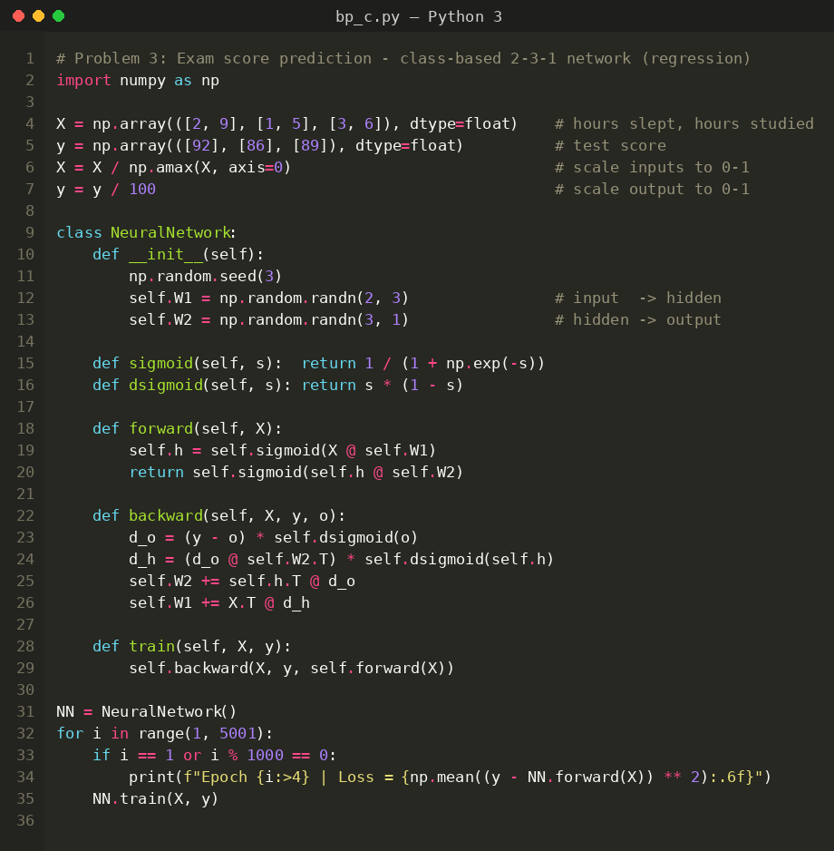
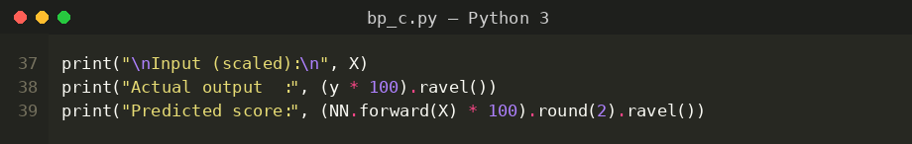
Input
Exam score data set: 3 training examples with 2 inputs (hours slept, hours studied) and the output test score. Inputs are scaled by their maximum value and the score is divided by 100.
Hours Slept | Hours Studied | Test Score
2 | 9 | 92
1 | 5 | 86
3 | 6 | 89
Output
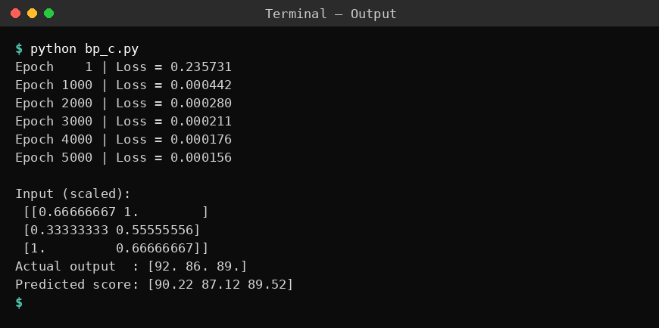
Result
The loss reduced from 0.235731 to 0.000156 after 5000 epochs. The network predicted the scores 90.22, 87.12 and 89.52 against the actual scores 92, 86 and 89, so the predictions are close to the targets.
Problem 4: Iris Flower Classification
Aim
To build a 4-8-3 neural network with a tanh hidden layer and softmax output, trained by backpropagation, to classify Iris flowers and measure the test accuracy.
Algorithm
- Initialise all weights and biases with small random values and choose a learning rate.
- Present a training input to the network and perform the forward pass: hidden output h = f(W1.x + b1) and network output o = f(W2.h + b2), where f is the activation function.
- Compute the error between the target t and the output o (mean squared error or cross-entropy).
- Backward pass: calculate the output-layer delta d_o = (t - o) * f'(o) and propagate it back to get the hidden-layer delta d_h = (W2 transpose . d_o) * f'(h).
- Update the weights and biases: W2 = W2 + lr * h transpose . d_o and W1 = W1 + lr * x transpose . d_h (biases are updated with the summed deltas).
- Repeat steps 2 to 5 for the required number of epochs, or until the error becomes small enough.
- Test the trained network on the training / test data and on a new sample to obtain the predicted output.
Program:
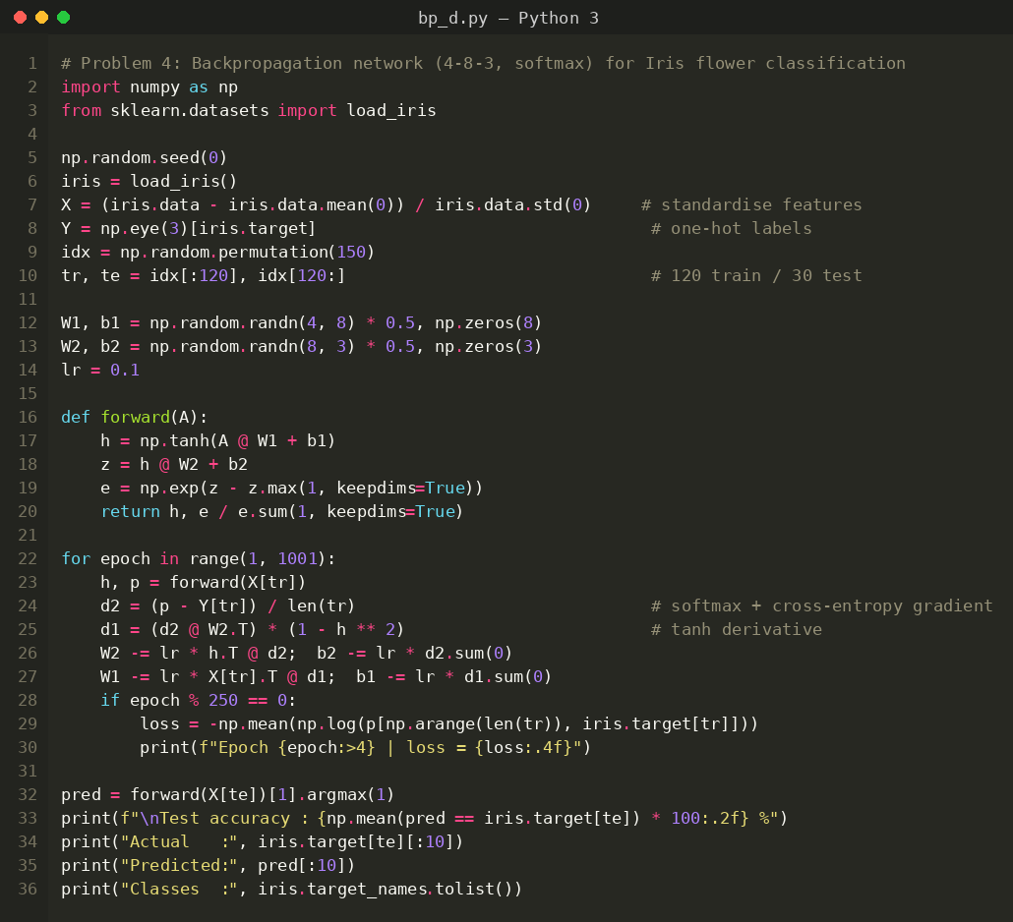
Input
Iris data set (loaded from scikit-learn): 150 samples, 4 features (sepal length, sepal width, petal length, petal width in cm) and 3 classes (setosa, versicolor, virginica). Features are standardised; 120 samples are used for training and 30 for testing. A few sample rows are shown below.
Sepal Length | Sepal Width | Petal Length | Petal Width | Class
5.1 | 3.5 | 1.4 | 0.2 | setosa
4.9 | 3.0 | 1.4 | 0.2 | setosa
7.0 | 3.2 | 4.7 | 1.4 | versicolor
6.4 | 3.2 | 4.5 | 1.5 | versicolor
6.3 | 3.3 | 6.0 | 2.5 | virginica
5.8 | 2.7 | 5.1 | 1.9 | virginica
Output
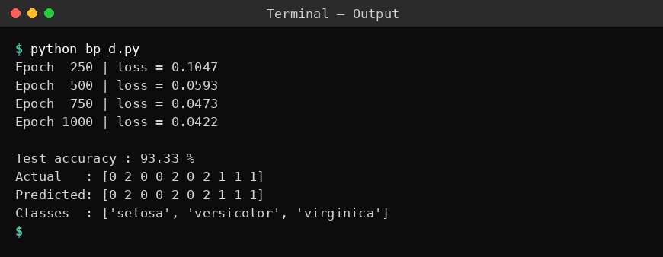
Result
The loss (cross-entropy) decreased from 0.1047 (epoch 250) to 0.0422 (epoch 1000). The trained network achieved a test accuracy of 93.33 % (28 of 30 test flowers), and the first ten predicted classes are the same as the actual classes.
Problem 5: Customer Purchase Prediction
Aim
To implement a reusable BackpropNet class with a tanh hidden layer and sigmoid output to predict whether a customer will buy a product, and to test it on a new customer.
Algorithm
- Initialise all weights and biases with small random values and choose a learning rate.
- Present a training input to the network and perform the forward pass: hidden output h = f(W1.x + b1) and network output o = f(W2.h + b2), where f is the activation function.
- Compute the error between the target t and the output o (mean squared error or cross-entropy).
- Backward pass: calculate the output-layer delta d_o = (t - o) * f'(o) and propagate it back to get the hidden-layer delta d_h = (W2 transpose . d_o) * f'(h).
- Update the weights and biases: W2 = W2 + lr * h transpose . d_o and W1 = W1 + lr * x transpose . d_h (biases are updated with the summed deltas).
- Repeat steps 2 to 5 for the required number of epochs, or until the error becomes small enough.
- Test the trained network on the training / test data and on a new sample to obtain the predicted output.
Program:
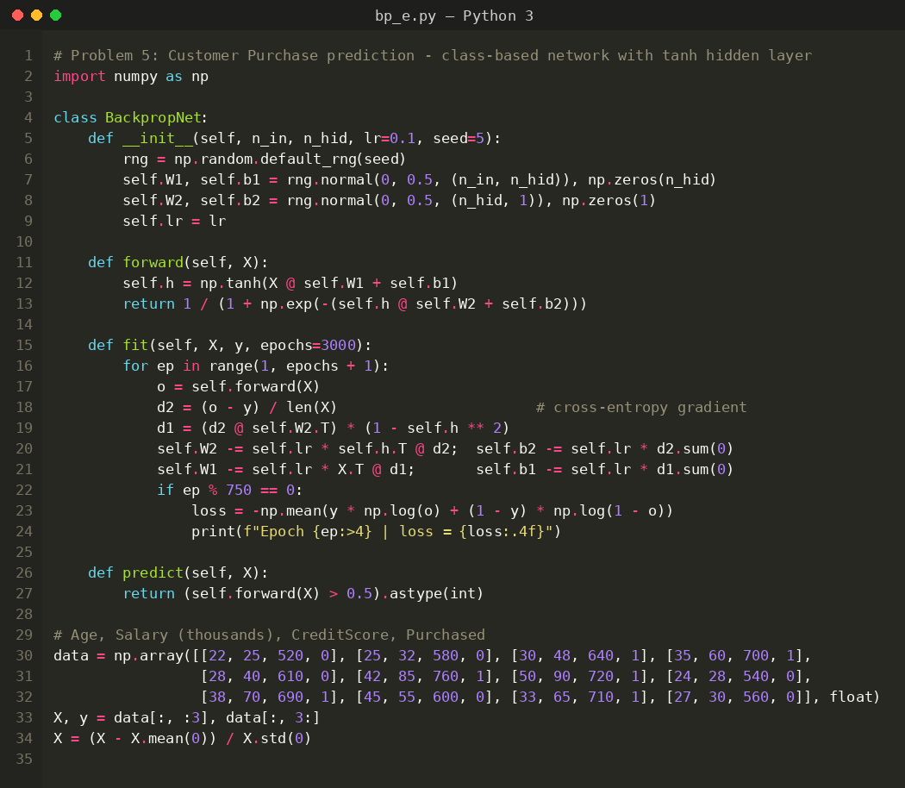
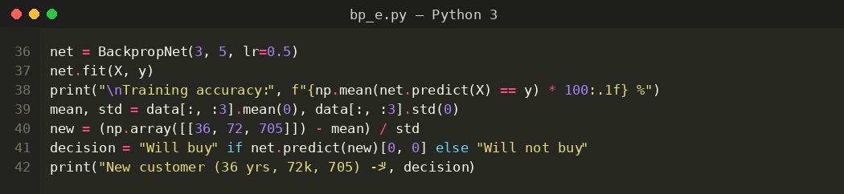
Input
Customer data set: 12 training examples with 3 inputs (Age, Salary in thousands, Credit Score) and the target Purchased (1 = Yes, 0 = No). Inputs are standardised. The new customer tested is (36 years, 72k, 705).
Age | Salary (k) | Credit Score | Purchased
22 | 25 | 520 | 0
25 | 32 | 580 | 0
30 | 48 | 640 | 1
35 | 60 | 700 | 1
28 | 40 | 610 | 0
42 | 85 | 760 | 1
50 | 90 | 720 | 1
24 | 28 | 540 | 0
38 | 70 | 690 | 1
45 | 55 | 600 | 0
33 | 65 | 710 | 1
27 | 30 | 560 | 0
Output
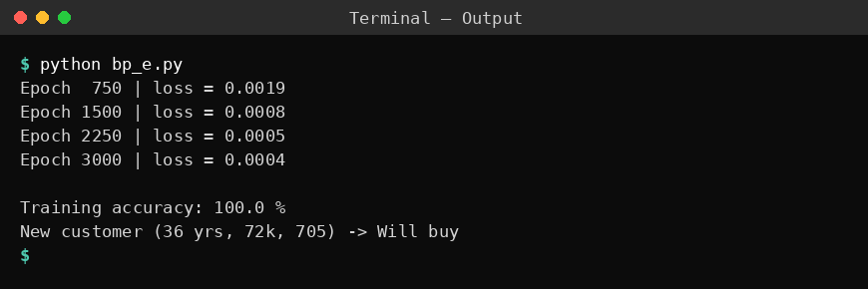
Result
The log-loss decreased from 0.0019 to 0.0004 over 3000 epochs and the training accuracy was 100 %. The new customer (36 years, salary 72k, credit score 705) is predicted to buy the product.

